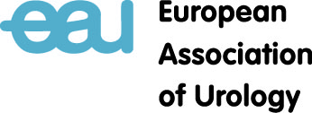
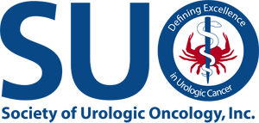

APPLICATION FORM
Society of Urologic Oncology Exchange Programme
A two-week scholarship in the USA for European Onco-Urologists

(Please print or type)

PERSONAL DATA:

Name: ....................................................................................................

Date of birth: ....................................................................................................

Mailing address: ....................................................................................................

...................................................................................................

...................................................................................................

E-mail address: ...................................................................................................

Phone and fax: ...................................................................................................

SIGNATURE:

……………………………………………………………………………………………………………………………………………………………
Signature Name Date

DEADLINE: applications must be received by JULY 15, 2022

E-mail the completed application, your curriculum vitae, a letter of recommendation, your list of publications and a 2 page written description of the unmet need, opportunity & plans to implement the knowledge upon returning to: i.grotenbreg@uroweb.org, or send it by regular mail to:
The EAU Central Office
Attention: Ilse Grotenbreg
Mr. E.N. Van Kleffensstraat 5
6842 CV Arnhem
The Netherlands
Phone: +31 26 389 06 80

